# 

# Exploring the Kibana Interface: Discover App

## Introduction

1. Alright, let’s begin exploring the interface, beginning with the Discover app.

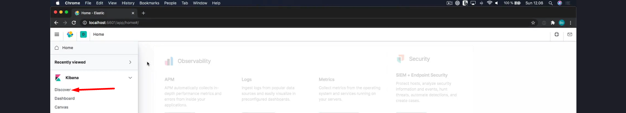

1.A Before we get into details with this app, there is one thing we need to talk about first; setting the time filter.

2. By default, the app displays data from within the past 15 minutes. That’s great under normal circumstances, where data is frequently indexed into Elasticsearch. In the case of HTTP access logs, documents would be streaming in quite frequently, and displaying data for the past 15 minutes would be useful.

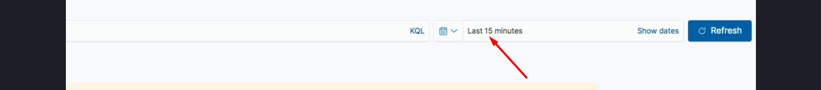

3. In our case, however, we need to change the time filter because the access logs that we used as our test data were for the first three months of 2020. That’s quite a bit in the past by now, so our documents don’t match the current time filter.

## The Time Filter

1. The time filter is actually super flexible and handy. If we click the small arrow, we will see a popover with a number of useful presets.

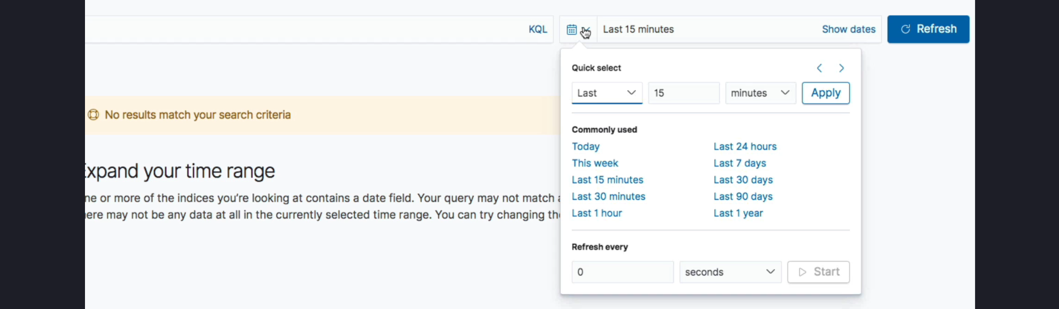

2. Here we can quickly define a time period, such as the past 15 days or five months. Let’s change the time filter to 15 days, for instance.

3. Apart from that, we can see a number of predefined presets, which are quite handy. We can also see our recently used date ranges, which is convenient if you need to switch between different date ranges.

4. We can also choose to have Kibana automatically refresh data based on an interval that we define.

## Setting an Absolute Date Range

1. To see any data, we need to define an absolute date range instead of one relative to the current time. We can do that by clicking “Show dates,” which will allow us to change each of the dates.

2. First, let’s choose the start date. Here we can choose an absolute date, which is what we need, so let’s click the “Absolute” tab.

3. Let’s choose the 1st of January 2020 at midnight. Now that’s done, let’s set the end date to March 31, 2020, one second before midnight. As for the time, I will enter that manually in the text field.

4. Alright, let’s click the “Update” button to apply the changes. All of our documents now match, because they are within the specified date range.

## Remembering Date Ranges

1. Kibana will remember this date range as you browse around. It might be reset under certain circumstances, in which case you can find the range that we configured within the recently used date ranges.

## How the Time Filter Works

1. So how does this time filter actually work? Under the hood, the index pattern that we created is actually used.

2. Remember how we chose which date field should be used to filter documents? That’s the field that is used for the time filter, being the @timestamp field in our case.

## Applicability of the Time Filter

1. Lastly, I want to mention that this time filter is actually not specific to the Discover app; a couple of other apps make use of this time filter as well, such as the Dashboard app.

## Next Steps

1. We are now almost ready to take a closer look at the Discover app, but first we need to talk about something called the Kibana Query Language.